**DS MINI PROJECT**

**TOPIC:ONLINE BANKING PORTAL**

**TEAM MEMBERS : -**

Romil Shah : 60004170096

Sanjay Nayak : 60004170101

Sarthik Bhat : 60004170102

**ABSTRACT:**

Online Banking Portal was selected as the project as it can be actually implemented across the banking sector on a large scale. Nowadays, there are increasing loads on the banks due to increase in customers and less number of open branches. In this growing era of digitalisation, where India needs to adapt the digital world in day-to-day life, this can be a small step towards complete digitalisation in the banking sector. This would also help the employees and the banking system to work with increased efficiency.

**Data Structures Used:** Linked List

Linked list was chosen to implement this idea because of its high efficiency , dynamic memory allocation property and programmer friendly approach. A linked list is a sequence of data structures, which are connected together via links. Linked List is a sequence of links which contains items. Each link contains a connection to another link. Linked list is the second most-used data structure after array because of its encapsulation properties. Each account was created using a completely new linked list . the linked list were linked in an ascending order of their customer ids.

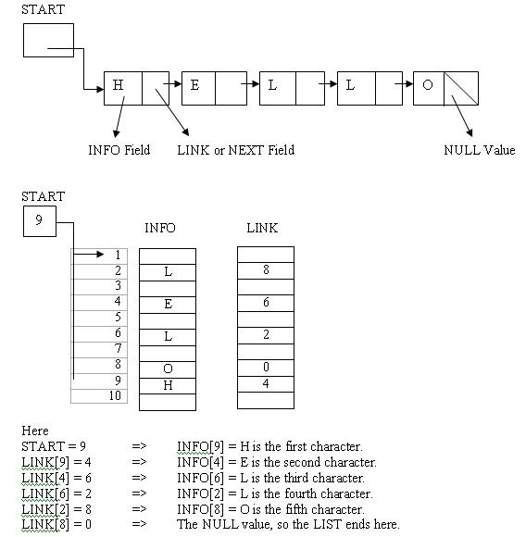

Symbolic representation of a linked list